The Role of Churches in Establishing Free Villages

The Non-Conformist Missionaries played a crucial role in helping the ex-slaves to form Free Villages. They either acted as bargaining agents for them, getting a ‘fair' price for the land and or accessing loans from their headquarters Church in England.
They bought large tracts of land, subdivided it and sold it in small plots to those who wanted it. Jamaica had a number of Free Villages that were formed this way. Most of them either bore the name of Abolitionists or places in the Bible or Christian traits, for examples: Clarksonville after Thomas Clarkson, Bethany and Harmony.
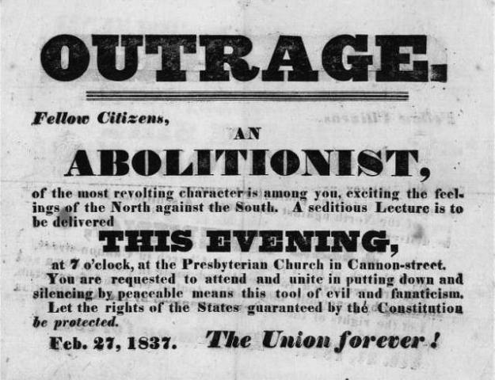
A poster proclaiming outrage at Abolitionists (from the American struggle against slavery)
These Missionary established Free Villages each had a Church at the center of its operations. During the week the Church building was used for school and even a day care center. Some offered evening classes to working adults. From this early the British government decided to allow the Non Conformist missionaries to provide elementary education to the masses. They were given a small sum of money to help them.
In British Guiana, the ex-slaves pooled their resources and bought entire estates through a co-operative venture. They then subdivided the land and each person received their share according to the money they had out in.

