The Kalinago

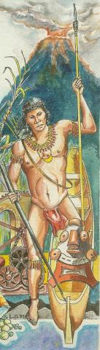

Political Structure

This was not as rigid or as well defined as the Tainos. The position of chief or Ouboutou (Ubutu) was not hereditary. It was NOT passed down from father to son. Instead, the chief was elected on the basis of his prowess that is his bravery. As a result there was constant rivalry for leadership. The leaders also changed frequently.
The chief's main duty was to organize the people in his community for hunting, fishing and war. He had the most duties during war time. He was responsible for planning the raids. He chose the captains of each canoe (piraga). A canoe could hold up to 50 persons! He shared out the prizes or rewards to those who were successful in the hunting expeditions or the raids.
At the end of an expedition he could lose his position if someone proved to be braver than he was. On their return home, that person would automatically replace him.
In peace time, the villages were ruled by the Tiubutuli Hauthe. He did not dispense justice that was considered to be a personal affair. If someone did you wrong, you were expected to avenge yourself. There were very few laws. The men were away too often on raids or hunting and fishing expeditions. When they were in the village, they spent most of their time undergoing warrior training.

Religious Beliefs and Practices
The Kalinagos were polytheistic. They also believed in many gods. They believed in evil spirits known as maboya. The priest had the power to pray to the gods to turn back evil.
They believed
- In the forces of evil
- In life after death
- In the existence of Heaven and hell
- That there is punishment and reward in the afterlife
- That those who were brave warriors went to a place where they were waited on by Tainos slaves.
- That the souls of cowards went to a dreary desert where they became slaves to Tainos masters.
- The priest or boyez was the only one who could communicate with the gods
- In offering sacrifices to the gods especially when they went to sea
- In using tobacco (incense) in the process of communicating with the gods
- In having festivals and celebrations in honor of the gods
- In keeping the gods happy (appeasing the gods)
- In offering prayers to the gods for bravery
Both the Tainos and the Kalinagos believed in nature and ancestor worship.

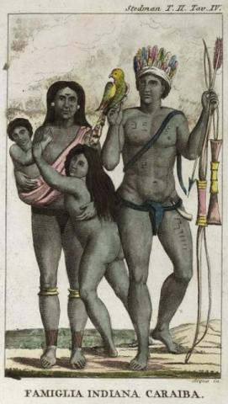

Gender relations
Women were also a very important part of the Kalinagos society. Gender relation is also most clearly seen in the division and organization of labor. The women were needed for the planting of the crops. It was believed that the fertility of the woman would transfer to the crop and vice versa. If she was barren, mother earth would transfer some of its fertility to her.
They were to care for the children and the rest of the family while the men were away on their raids, long hunting or fishing trips.
The women were only invited to watch at wrestling matches. They were not allowed to participate. They formed the cheering committee. Men and women lived separate. The men believed that they would become weak and be like ‘sissy' if they lived with the women. So the men lived together in the carbet while the women and children lived by themselves. The boys were then separated from their mothers. At age ten they joined the men in the carbet and began to prepare for their manhood initiation ceremony.
Customs
1. Men and women lived separately
2. Painting of the body to look fierce especially when going on raids
3. They did not eat turtle. They thought it would make them slow and stupid
4. They ate a lot of pepper. It was believed that this would make them fierce

5. They flattened their foreheads from an early age. This was to make the arrow
bounce off should they get hit in the forehead during battle.
6. They often hung the skull and or bones of their victims in their houses like
trophy.
7. All boys were required to undergo initiation test when they reached puberty.
8. They were scratched with an agouti claw and pepper rubbed in the wound. If
they bore it without flinching they were chosen to be a warrior. If they
flinched, they would be numbered among the priests.

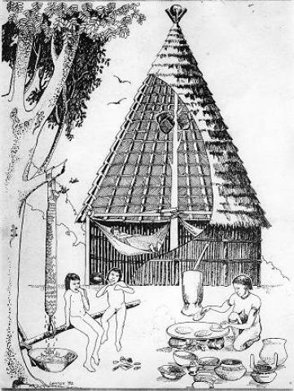
Kalinagos cultre
Technology
1. Poisonous bow and arrow
2. Weaving straw baskets

