The Dealings of Government after Emancipation

We have already pointed out that very little provisions were made for the newly emancipated people. No public health system or housing scheme was put in place to accommodate them. The laws did not address the matter of their legal and voting rights. It was the Missionaries who gave them guidance and support in these unfamiliar areas.
All of these problems and more led the peasants in St. Vincent (1862) and Jamaica (1865) and Barbados (1876) to stage a rebellion in their respective territory.
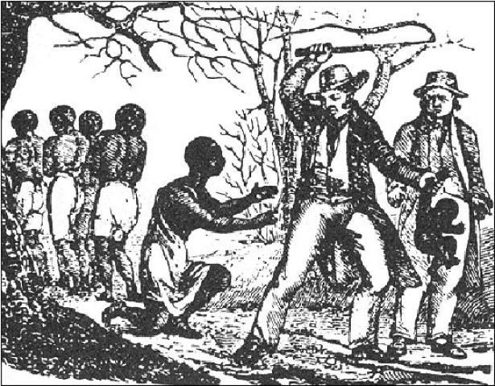
A slave having their child taken away, depriving them of rights and forcing them into revolt
The government felt that it had done enough. It had partnered with the Churches in providing elementary education for the masses. For ten years through the Negro Education grant, it helped to finance education. From 1835 to 1840 it provided an annual sum of thirty thousand pounds to help finance education. The amount decreased gradually for the next five years until it ceased in 1845.
In addition they took the initiative to use the Mico Trust Charity Fund of $120,000, to open a number of schools. These were operated by religious bodies in colonies such as Jamaica, St. Lucia, Dominica and Trinidad. By 1841, just three years after emancipation there were about 196 schools throughout the British Caribbean with a school population of about 1,500. Government inspectors were appointed and commissioned to supervise the education system.
The truth is that after this very little was done. Once the Imperial Government withdrew or ceased funding, the local government authorities refused to vote any significant amount of money for education of the masses. It was in their best interest to keep the masses ignorant. It would ensure labor for their estates and enterprises and secure their class from any the entrance of any lower class people. Primary education was not seen as necessary or compulsory (except in British Guiana). How then could the masses reach any further?
The authorities had the same attitude towards public health and housing. The Old Representative System of government was anything but representative. The composition of it was mainly plantocrats and upper class whites with a few colored members. These people did not care about the suffering of the masses.
The 1850's and 1860's brought further distress on the already frustrated masses:
- Cholera epidemic claimed the lives of thousands and left many children orphaned and families without the main breadwinner (income earner)
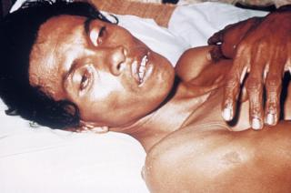
A man sick with Cholera
- 1861-1865 was the American Civil War. This meant that essential food supply- flour and saltfish- was not available. The shortage of food sent the prices ‘sky high'. Bread and flour went up by as much as 83%!
- 1863-1865 were years of drought and other natural disasters
No relief was provided. What followed next is a prime example of how the Representative government dealt with the demands of the freed people.
The people in the parish of St. Ann, Jamaica, sent a petition to the Queen Victoria. She sent an unkind reply. She advised them to work hard for whatever wages they were offered and find ways to help themselves. What an insult! The biased and racist governor Eyre loved the response. It seemed to give him approval for his draconian way of dealing with the masses that he treated with open disdain. He published thousands of copies, held public readings of them and had them posted all over different towns.
He treated Paul Bogle with open disdain. The peasants from St. Thomas dared to seek audience with him. He had no time to listen to the grievances of peasants. It did not matter to him that Bogle and his marching band had walked more than sixty miles to see him! They returned to Morant Bay in St. Thomas were only a few days later the Morant Bay Rebellion led by Bogle erupted.

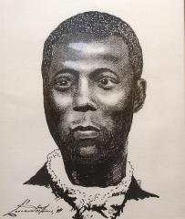
Paul Bogle
The governor quickly proclaimed martial law. As usual their first response was force and repression! The militia was called out to suppress the rebellion. Ringleaders were caught, brutally and publicly flogged and then hung.
This forced the Imperial government to change its response. It effected a change from the Old Representative System to Crown Colony government. All colonies EXCEPT Barbados instituted this new form of government. It was more responsive to the needs of the public but the attitude of control and superiority was basically the same.
Reforms of Crown Colony Government
- Public works: roads, bridges etc.
- Police Force
- District Courts
- Social services : Boards of Health, Government Hospitals constructed

