Social Contribution of Immigrants
1. New races were introduced. This resulted in a permanent change in the social composition of the colonies.
2. Sexual relationships between the Asian immigrants (Chinese and East Indians) and the Negroes resulted in a further mixing of the races. In Trinidad and British Guiana, a person of such mixed descent was termed a ‘doogla.'
3. The introduction of a new language. Though the masses never really learnt the Chinese or Hindu language, one could enter a Chinese shop and hear the Chinese language as they communicated with each other.
4. Islam was not new to the Western Hemisphere but the coming of the immigrants expanded the membership and presence of this religion. In addition Hinduism was introduced.
5. New festivals were introduced. Some of these are Divali, Hosein and Holi. The masses were attracted by the food and the color. Some of them joined the various processions.
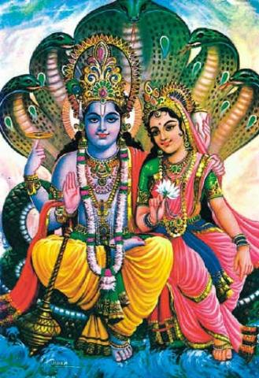
Divali
6. The Chinese opened restaurants and ice cream parlors adding to the variety of recreational activities that the masses could enjoy.
7. In Trinidad, the number of schools increased as particular schools were built for the children of East Indian immigrants. These were known as ward schools.
8. New foods were introduced. This includes the now famous curry seasoning, roti and a host of Chinese dishes.
9. The Chinese and Indians made the eating of rice popular.
Despite the positive contributions of these new groups of people there were a few negative effects of their coming. They themselves had a difficult time adjusting to life in the Caribbean. They came from the east, different culture and different languages. They arrived in a society that was largely controlled by the white plantocracy.
The ruling class was very prejudiced. They practiced open racial discrimination. They considered themselves superior to every other race and class. As a result the newcomers faced basically the same kind of treatment that the blacks received:
- Restriction of movements made them feel trapped and enslaved on the estates.
- Planters underpaid them. In some cases they owed them for long periods. Some never bothered to pay the arrears at all.
- Partiality of the courts in favor of the whites
- Physical and verbal abuse on and off the estates. The East Indians in particular were called some unkind names. The fact that they tend to stick to their races only did not help the tension between the races at all.
- Tropical diseases were a serious challenge
- The planters did not provide adequate food or medical care. The housing conditions were unsanitary.
- Some of the Indians were from the lower caste or the untouchables. Those immigrants who were from a higher caste kept the caste system and did not mix with them. A number of them dealt with their loneliness by becoming drunkards.

