Problems of the Peasantry

- First of all they were charged high prices for what was more often than not, hilly and or infertile land in remote areas.
- They had problem obtaining proper titles for their land. They were often told that the land was not officially surveyed. What did this mean to an illiterate peasant? The spiteful planters were trying to prevent the peasants from exercising their right to vote. The right to vote was extended to persons with a certain amount of property.
- The colonial authorities refused to allocate government funds to fix or construct roads in the remote areas
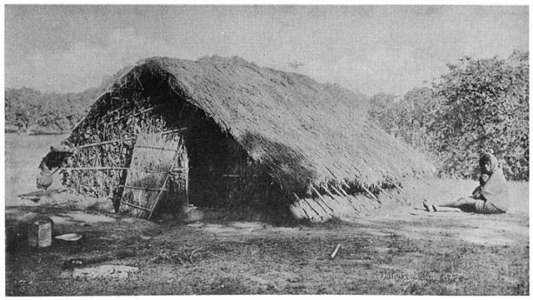
A Peasant hut
- The peasants had a hard time getting their produce to the market
- The colonial legislatures charged high land tax on the small holdings of the peasants
- They further transferred the tax burden to them by charging more tax for a donkey (cart) than a horse!
- They suffered from praedial larceny.
- Then were the acts of nature: hurricane, droughts and all sorts of plant diseases
- Later on they received stiff competition or unfair prices from large companies such as the United States Boston Fruit Company
- They often lacked the money to buy and replace fertilizers, small equipment and tools such as machetes and hoes.
- They received no help from the local authorities or the Mother Country. In fact they were indifferent to their plight. They clung conveniently to the stereotype of the blacks as lazy.

