Free Villages

Free villages were settlements that were formed independent of the estates. Majority of these were formed after Emancipation. Antigua and Jamaica has the distinction of Free Villages being formed during 1834-1838.

What conditions gave rise to the establishment of these Free Villages?
1. The freed people wanted to be truly free. They wanted to leave the estates and make a life for themselves. A man does not feel like a man until he is ‘turning his own key'.
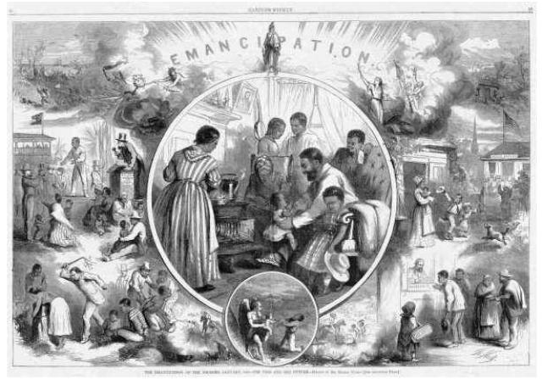
Emancipation- hope of a better life

2. The availability of land. In some colonies land that was not suitable for sugar cultivation was available for sale. The hilly colonies of Jamaica, St. Lucia and Grenada are perfect examples.
3. In a number of the territories land also became available after the 1850's. A number of planters responded to the challenges of Emancipation by closing down their estates and returning to England. Some of these abandoned estates were later sold in small plots to pay off debts.
4. The colonial authorities in some colonies offered Crown land for sale. Governor Colebrook of Antigua in the 1840's saw this as a way to attract the emancipated people to work on nearby estates.
5. During the Apprenticeship system some apprentices were able to work for wages which they saved. Added to the savings from the Saturday market sales, they were able to purchase small plots of land.

