Hinduism and the Region
How did the religions of the region influence social life?
HINDUISM
The East Indian immigrants introduced this new religion to the region. It was different because of its doctrines and practices. First of all, the Hindus were polytheistic. That is they believed in many gods whereas Christians believe in One God. To make matters worst these gods were represented by images of animals. There was one god who was an elephant and another was part monkey. This was ridiculous if not sacrilegious to the Christians and those of the African religions.
They also believed in reincarnation and animism that is that all things have life. The Vedas was their scripture. It is these beliefs and practices that gave the immigrants the hope and strength that they needed to endure the harsh conditions that they faced on the estates in particular and in the Caribbean society in general. They buried their dead on a pyre. The Africans thought this was disrespectful.
They met to worship and formed important links and friendships. Some met their partners and got married.
But there was also another feature of their religion that sparked some positive connection with the masses. Their food and spices were adopted by a number of people.

Rastafarianism
The Rastafarian movement began in Jamaica in the 1940's. It began as a rebel movement against the oppression and exploitation of colonialism. Rastas reject European social standards. They see whites as oppressors, the ones who introduced slavery to the Caribbean. They were the ones who dragged their forefathers across a continent and enslaved them. After slavery whites remained the rulers and continued their oppression and exploitation of the black race.
Its founder Leonard Howell was an ardent supporter of Garvey and his philosophies and program. He was especially attracted to the teachings regarding Africa being the homeland of all Africans, the back to Africa movement and the idea of blacks worshipping a black divine being. They also preached racial pride and dignity.
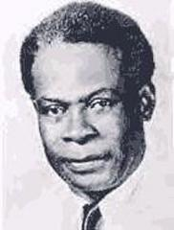
Leonard Howell
They proclaimed Emperor Haile Selassie of Ethiopia as god. The fact that he is from the lineage of David and was crowned with the title king of kings and lords of lords seemed to confirm Garvey's prophecy that Africans should look for a black god. According to Rastafarians this fits in also with prophecies from the Bible.
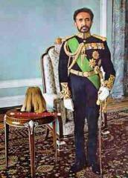
Emperor Haile Selassie
They follow a strict code of conduct with regards to diet and dress. They do not eat pork. They consider the pig to be an unclean animal. They are mostly vegetarians. A few eat fish. They eat strictly ital, which means that their food is cooked or prepared without salt. They believe that all herbs and trees are given for food and healing. They constructed their own language. They greet each other with the term ‘blessed love'. They refer to themselves as I and I. the word ‘irie' is originally theirs.
They dress in the colors of Marcus Garvey: red, green and gold. They are fully clad from head to toe and usually wear sandals that they make. They sport a dreadlock which means that they wear their hair matted and uncombed. They are supposed to look fierce and lion like. Members of the upper class in particular began to spread propaganda against the Rastafarians claiming that they were untidy and even smelly.

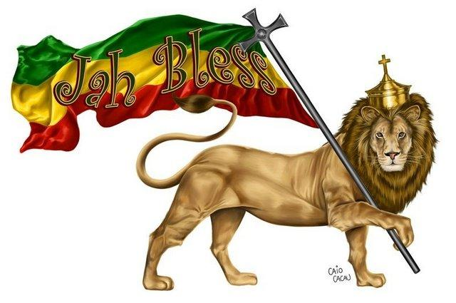
Lion of Judah
They engaged in growing provisions, corn, cassava, yam and fruits and vegetables: chiefly for their own use. They also made brooms, mats and other craft items which they sell for a living. They are famous also for their music. The beating of drums and the chanting of their god's name: Jah Rastafari accompanied by the titles, ever living, ever faithful and ever sure scared quite a few children. They smoked ganja as part of their religious rituals. Their pipes which they also made were called chalice.
They were ostracized by the society in general. The Christian community found their doctrines blasphemous. The colonial authorities saw them as dangerous. They were heavily persecuted and hunted down like common criminals. On the orders of those in charge, police raided their settlements, beat the men and carried them off to jail frequently on the charge of being disorderly.
It is no wonder then that the Rastafarians called the police Babylon. This term is also loosely applied to anything that the white man is said to have created or is a part of. This includes the King James Version of the Bible. The Rastafarians use the Maccabees version instead. They read and study their Bible in depth.
The parents of upper and middle class children feared for their daughters and sons. They feared that their daughters would fall in love with a Rasta and be carried off into the hills to become his queen and have his children. Rastas do not believe in the sacrament of marriage. They believe that once you take a woman unto yourself and call her queen that's it. They do NOT believe in contraception either. They see it as a plot to ‘kill out black people'.

Islam and the Region
How did the religions of the region influence social life?
ISLAM
Some Africans were Muslims but they had to abandon this when they were forcibly transported to the West Indies. This religion revived with the introduction of the East Indian immigrants.
The central figure of this religion is the Prophet: Mohammed. Muslims believe in one God. His name is Allah. There were five important pillars which each Muslim had to practice on a daily basis. They had to pray three times a day at particular hours facing Mecca. The masses felt that this was too demanding. It would not fit in with the strenuous workload that they had to carry.
Gender Relations
The man of the house had ultimate power in house matters and decision making. Women were not allowed to be educated. Fathers sent sons but not daughters to school. At the mosque or masjid, the men sat together at the front while the women huddled together at the back.
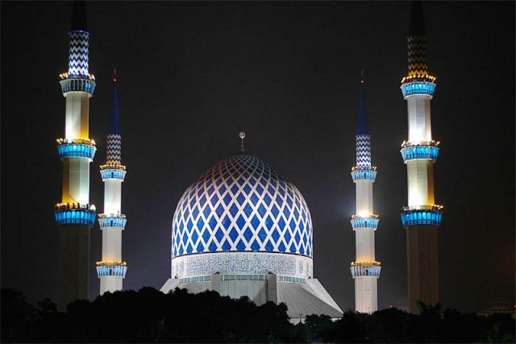
Masjid
Family Life
Men were the head of the house hold Women were home makers. They stayed home and raised the children. Boys were considered more important than girls and were generally privileged. Both Hindus and Muslims practiced arranged Marriages and got married at an early age. Most women did not leave their home without a veil covering their hair and sometimes a robe covering their clothing. They were teased for their dress and beliefs.
Muhammed Khan came to Jamaica in 1915 and built Masjid Ar-rahman in Spanish Town (1957) Masjid Hussein (another organization) was built in Westmoreland. British Guiana and Trinidad had the largest Muslim population and number of Mosques since they received the most East Indians in the migrants during the period of slavery.
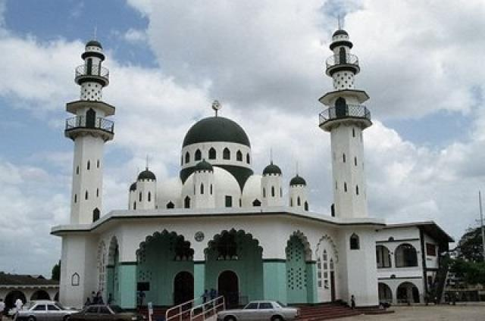
The Mosque in Port of Spain, Trinidad, Trinidad and Tobago
Festivals
The festivals were most commonly practiced in Trinidad and Guyana. The two most known festivals are Ramadan and Hosein. A number of the lower classes found the thrill, color and pageantry of Hosein very attractive and they would actually join the processions.
Ramadan is the 9th month of the Islamic lunar Calendar. During this month Muslims all over the world abstained from food drink and pleasure. Young children, elderly, chronically ill and the pregnant were exempted. This was conducted in order to purify the soul and reconnect with God. This was something that African men felt they definitely could not manage!
Conflicts
Name calling: some were scorned due to the fact that some blacks were Muslim. They were ridiculed by other religions because of the five pillars (praying five times a day)

Christianity and the Region
How did the religions of the region influence social life?
CHRISTIANITY
1. The Christian Churches taught the following about gender:
(i) The men were superior to the women
(ii) The man was the head of the household
(iii) The women were to stay at the home and take care of the children and home life while the men worked
(iv) Church men were given leadership positions; e.g. Local preachers, Deacons, Priests
2. They provided recreational and educational facilities
3. They did valuable charity work such as operating soup kitchens and day care for desperate mothers.
4. They conducted informal adoptions. Some of the Missionaries themselves adopted and took care of orphaned or less advantaged children. They operated Boys and Girls Homes.
5. They provided a wide range of occupation for lower class people, allowing them a measure of social mobility: clergy men, deacons, watchmen of the church grounds and caretakers.
6. Health Practices: The Church taught that "cleanliness is next to godliness". Members were therefore encouraged to practices good hygiene.
Diet: some denominations such as Seventh Day Adventists taught their followers to abstain from eating certain foods such as pork and beef. They had a vegetarian diet.
7. Conflict: in the early period (1838-1850) the blacks experienced much discrimination when they tried to worship in the Christian churches such as the Anglican and the Catholic churches. They were required to sit at the back. The services were conducted partly in English and partly in Latin. They did not understand much. The way it was conducted was outside of their culture and experience. They were not asked to do much. They found the exercise quite boring.

The Difficulties and Challenges in Practising Festivals
Difficulties and obstacles faced by the organizers and participants in their attempts to practice these festivals.
1. As more and more persons became converted to Christianity the number of Indians in particular who were willing to participate in the festival dwindled. This was because of the Christian leaders' condemnation of some of these festivals which they saw as wrong. As a result the organizers lost the financial support of some of its most faithful supporters.
2. Wages were kept deliberately low. Some of the festivals required funding such as the tazias building and the gift giving. This prevented some of those who would have wished to participate from becoming involved.
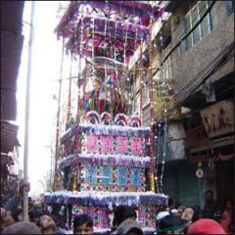
A Tazia
3. There are particular cases to consider. For example the 1860's was a difficult time for the entire Caribbean. It all started with the American Civil War (1861). There was a massive increase in the price of imported foodstuff. Flour, a main meal item for the masses rose by eight three per cent! (83%) The cost of living rose by sixty per cent (60%). In order to cushion the blow for themselves, the authorities imposed heavy and new taxation on the masses. For example, carts were previously untaxed but after 1864 the owners (who are obviously those of the poorer class) were required to pay eighteen shillings per year on their carts! You can well understand how, in the context of low wages, this would result in their inability to buy gifts for festivals or sponsor tazia building and so on.
4. The Caribbean region is prone to droughts and hurricanes. 1862 and 1863 saw a series of droughts throughout the region. This was followed by heavy rains the next year. The result? Flooding and destruction of crops, roads bridges etc., You can well imagine that the harvest festival would either have to be postponed or cancelled for that year.
5. Each successive generation became less and less interested in the culture and practices of their forefathers. This was partly because they spent more and more time at school. As they became more and more educated and exposed to other cultures they became more and more integrated, they made friends with children from other races and did not want to be seen or stand out as different.
6. In some instances potential leaders of the ceremony and men of influence became more involved in the formation and fight to legalize Trade Unions (1930's) and their political careers or aspirations for political office in the 1950's and 1960's when Constitutional changes were taking place in the British Caribbean and a number of coveted posts were made available.
7. The upper class opposed these cultures. The rowdy behaviour, the rum drinking and the loud music were seen as barbaric and uncivilized. They made no attempt to understand the new cultures that were injected into the society instead they reacted with scorn and derision. For example in 1884 the Governor of Trinidad passed a law, placing certain restrictions on the Taziya procession. A Proclamation was issued to the East Indians of Naparima, (Trinidad) notifying them that they would NOT be allowed to pass through San Fernando.
8. Those members of the lower classes who managed to send their children to schools desired for them a better way of life. Very often this ‘better way of life' meant aspiring to the values and traditions of the upper class.
9. The Americanization of the Caribbean led to a lot of culture erosion. This was especially so after the American soldiers spent some six years in the Caribbean on the different bases. Persons became more attracted to the American culture- the rock and roll music, the seductive moves of Elvis ‘the pelvis' Presley and certainly after the late 1950's for those who could afford it television became the centre of attraction not festivals and celebrations! A number of persons lost their taste for ‘those things'.

African Religions
Orisha is a religion of the Yoruba people of West Africa. This is a monotheistic religion. They believe in one supreme being who communicates with his followers through emissaries called Orishas. Participants sing until they fall into a trance and are possessed by the spirits. In Trinidad, the shango religion is believed to be derived from the Orisha. They share the same rituals and practices, except that their god is the god of thunder and lightning (shango). It also has a mixture of Catholicism with the Baptist faith.
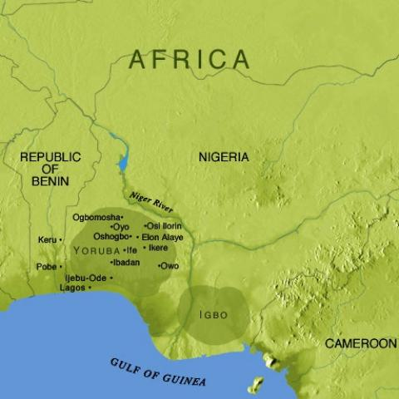
Map showing Yoruba

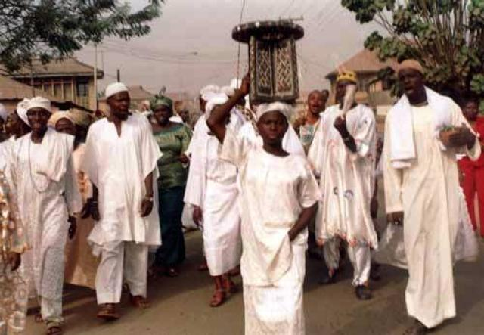
Yoruba people
Revivalism
They also believe in spirit possession. Their dress is distinctive. They wear robes of either white, blue and or red. Their heads are wrapped. Some even wear a pair of scissors in their hair. Men are often seen with a pencil behind their ears. They see themselves as messengers of God. They give this message in public places where they are sure to be heard. Many claim that they can ‘read' a person. That means that they can look at a total stranger and tell what is happening in their life. Women play a leading role in this religion. They are known as ‘mother'.
Their place of worship often has a basin or bottles of water at the altar. Some carry a flag or flags of red, blue to identify it as a sacred place. Music and dance are important to the ceremony. They do not sing traditional English or American hymns used in the traditional Christian churches. Someone ‘tracks' the song, that is they say the words mostly from memory and the others sing after them. Their drums have a distinctive beat. Men and women dance and gyrate as they are ‘possessed' by the spirit. Some even ‘turn around in circles' or are spun by others. This is known as ‘turn your roll'.
This religion is seen as a cult by Christian community. They do not mix with them. Some people are afraid of them because they believe that they are actually mixing with evil (demons).
Spiritual Baptists
Practices: They believed in communicating with departed spirits and that they briefly inhabit the bodies of the faithful. The purpose of this is so that the ancestors could share their wisdom. Songs were often sung during rituals. Some did chanting.

